**CHAPTER-1**

**MATLAB**

**1.1 INTRODUCTION TO MATLAB**

MATLAB® is a high-performance language for technical computing. It integrates computation, visualization, and programming in an easy-to-use environment where problems and solutions are expressed in familiar mathematical notation. Typical uses include

Math and computation

Algorithm development

Data acquisition

Modelling, simulation, and prototyping

Data analysis, exploration, and visualization

Scientific and engineering graphics

Application development, including graphical user interface building.

MATLAB is an interactive system whose basic data element is an array that does not require dimensioning. This allows you to solve many technical computing problems, especially those with matrix and vector formulations, in a fraction of the time it would take to write a program in a scalar non interactive language such as C or FORTRAN.

The name MATLAB stands for matrix laboratory. MATLAB was originally written to provide easy access to matrix software developed by the LINPACK and EISPACK projects. Today, MATLAB engines incorporate the LAPACK and BLAS libraries, embedding the state of the art in software for matrix computation.

MATLAB has evolved over a period of years with input from many users. In university environments, it is the standard instructional tool for introductory and advanced courses in mathematics, engineering, and science. In industry, MATLAB is the tool of choice for high-productivity research, development, and analysis.

MATLAB features a family of add-on application-specific solutions called toolboxes. Very important to most users of MATLAB, toolboxes allow you to learn and apply specialized technology. Toolboxes are comprehensive collections of MATLAB functions (M-files) that extend the MATLAB environment to solve particular classes of problems. Areas in which toolboxes are available include signal processing, control systems, neural networks, fuzzy logic, wavelets, simulation, and many others.

**1.2 The MATLAB System:**

The MATLAB system consists of five main parts:

**1.2.1 Development Environment**:

This is the set of tools and facilities that help you use MATLAB functions and files. Many of these tools are graphical user interfaces. It includes the MATLAB desktop and Command Window, a command history, an editor and debugger, and browsers for viewing help, the workspace, files, and the search path.

**1.2.2 The MATLAB Mathematical Function:**

This is a vast collection of computational algorithms ranging from elementary functions like sum, sine, cosine, and complex arithmetic, to more sophisticated functions like matrix inverse, matrix eigen values, Bessel functions, and fast Fourier transforms.

**1.2.3 The MATLAB Language:**

This is a high-level matrix/array language with control flow statements, functions, data structures, input/output, and object-oriented programming features. It allows both "programming in the small" to rapidly create quick and dirty throw-away programs, and "programming in the large" to create complete large and complex application programs.

**1.2.4 Graphics**

MATLAB has extensive facilities for displaying vectors and matrices as graphs, as well as annotating and printing these graphs. It includes high-level functions for two-dimensional and three-dimensional data visualization, image processing, animation, and presentation graphics. It also includes low-level functions that allow you to fully customize the appearance of graphics as well as to build complete graphical user interfaces on your MATLAB applications.

**1.2.5The MATLAB Application Program Interface (API):**

This is a library that allows you to write C and Fortran programs that interact with MATLAB. It includes facilities for calling routines from MATLAB (dynamic linking), calling MATLAB as a computational engine, and for reading and writing MAT-files

**1.3 MATLAB WORKING ENVIRONMENT:**

**1.3.1 MATLAB DESKTOP:**

Matlab Desktop is the main Matlab application window. The desktop contains five sub windows, the command window, the workspace browser, the current directory window, the command history window, and one or more figure windows, which are shown only when the user displays a graphic.

The command window is where the user types MATLAB commands and expressions at the prompt (>>) and where the output of those commands is displayed. MATLAB defines the workspace as the set of variables that the user creates in a work session. The workspace browser shows these variables and some information about them. Double clicking on a variable in the workspace browser launches the Array Editor, which can be used to obtain information and income instances edit certain properties of the variable.

The current Directory tab above the workspace tab shows the contents of the current directory, whose path is shown in the current directory window. For example, in the windows operating system the path might be as follows: C:\MATLAB\Work, indicating that directory "work" is a subdirectory of the main directory "MATLAB"; which is installed in drive C. clicking on the arrow in the current directory window shows a list of recently used paths. Clicking on the button to the right of the window allows the user to change the current directory.

MATLAB uses a search path to find M-files and other MATLAB related files, which are organize in directories in the computer file system. Any file run in MATLAB must reside in the current directory or in a directory that is on search path. By default, the files supplied with MATLAB and math works toolboxes are included in the search path. The easiest way to see which directories are on the search path. The easiest way to see which directories are soon the search path, or to add or modify a search path, is to select set path from the File menu the desktop, and then use the set path dialog box. It is good practice to add any commonly used directories to the search path to avoid repeatedly having the change the current directory.

The Command History Window contains a record of the commands a user has entered in the command window, including both current and previous MATLAB sessions. Previously entered MATLAB commands can be selected and re-executed from the command history window by right clicking on a command or sequence of commands. This action launches a menu from which to select various options in addition to executing the commands. This is useful to select various options in addition to executing the commands. This is a useful feature when experimenting with various commands in a work session.

**1.3.2 Using the MATLAB Editor to create M-Files:**

The MATLAB editor is both a text editor specialized for creating M-files and a graphical MATLAB debugger. The editor can appear in a window by itself, or it can be a sub window in the desktop. M-files are denoted by the extension .m, as in pixelup.m. The MATLAB editor window has numerous pull-down menus for tasks such as saving, viewing, and debugging files. Because it performs some simple checks and also uses color to differentiate between various elements of code, this text editor is recommended as the tool of choice for writing and editing M-functions. To open the editor , type edit at the prompt opens the M-file filename.m in an editor window, ready for editing. As noted earlier, the file must be in the current directory, or in a directory in the search path.

**1.3.3 Getting Help:**

The principal way to get help online is to use the MATLAB help browser, opened as a separate window either by clicking on the question mark symbol (?) on the desktop toolbar, or by typing help browser at the prompt in the command window. The help Browser is a web browser integrated into the MATLAB desktop that displays a Hypertext Markup Language(HTML) documents. The Help Browser consists of two panes, the help navigator pane, used to find information, and the display pane, used to view the information. Self-explanatory tabs other than navigator pane are used to perform a search.

**CHAPTER-2**

**DIGITAL IMAGE PROCESSING**

**2.1 Introduction To Image Processing:**

Digital image processing is an area characterized by the need for extensive experimental work to establish the viability of proposed solutions to a given problem. An important characteristic underlying the design of image processing systems is the significant level of testing & experimentation that normally is required before arriving at an acceptable solution. This characteristic implies that the ability to formulate approaches &quickly prototype candidate solutions generally plays a major role in reducing the cost & time required to arrive at a viable system implementation.

**2.2 What is DIP?**

An image may be defined as a two-dimensional function f(x, y), where x & y are spatial coordinates, & the amplitude of f at any pair of coordinates (x, y) is called the intensity or gray level of the image at that point. When x, y & the amplitude values of f are all finite discrete quantities, we call the image a digital image. The field of DIP refers to processing digital image by means of digital computer. Digital image is composed of a finite number of elements, each of which has a particular location & value. The elements are called pixels.

Vision is the most advanced of our sensor, so it is not surprising that image play the single most important role in human perception. However, unlike humans, who are limited to the visual band of the EM spectrum imaging machines cover almost the entire EM spectrum, ranging from gamma to radio waves. They can operate also on images generated by sources that humans are not accustomed to associating with image.

There is no general agreement among authors regarding where image processing stops & other related areas such as image analysis& computer vision start. Sometimes a distinction is made by defining image processing as a discipline in which both the input & output at a process are images. This is limiting & somewhat artificial boundary. The area of image analysis (image understanding) is in between image processing & computer vision.

There are no clear-cut boundaries in the continuum from image processing at one end to complete vision at the other. However, one useful paradigm is to consider three types of computerized processes in this continuum: low-, mid-, & high-level processes. Low-level process involves primitive operations such as image processing to reduce noise, contrast enhancement & image sharpening. A low- level process is characterized by the fact that both its inputs & outputs are images.

Mid-level process on images involves tasks such as segmentation, description of that object to reduce them to a form suitable for computer processing & classification of individual objects. A mid-level process is characterized by the fact that its inputs generally are images but its outputs are attributes extracted from those images. Finally higher- level processing involves "Making sense" of an ensemble of recognized objects, as in image analysis & at the far end of the continuum performing the cognitive functions normally associated with human vision.

Digital image processing, as already defined is used successfully in a broad range of areas of exceptional social & economic value.

**2.3 What Is An Image?**

An image is represented as a two dimensional function f(x, y) where x and y are spatial co-ordinates and the amplitude of 'f' at any pair of coordinates (x, y) is called the intensity of the image at that point.

**2.4 Gray Scale Image:**

A gray scale image is a function I (xylem) of the two spatial coordinates of the image plane.

I(x, y) is the intensity of the image at the point (x, y) on the image plane.

I (xylem) takes non-negative values assume the image is bounded by a rectangle [0, a] [0, b]I: [0, a] [0, b] [0, info)

**2.5 Colour Image:**

It can be represented by three functions, R (xylem) for red, G (xylem) for green and B (xylem) for blue.

An image may be continuous with respect to the x and y coordinates and also in amplitude. Converting such an image to digital form requires that the coordinates as well as the amplitude to be digitized. Digitizing the coordinate's values is called sampling. Digitizing the amplitude values is called quantization.

**2.6 Coordinate Convention:**

The result of sampling and quantization is a matrix of real numbers. We use two principal ways to represent digital images. Assume that an image f(x, y) is sampled so that the resulting image has M rows and N columns. We say that the image is of size M X N. The values of the coordinates (xylem) are discrete quantities. For notational clarity and convenience, we use integer values for these discrete coordinates.

In many image processing books, the image origin is defined to be at (xylem)=(0,0).The next coordinate values along the first row of the image are (xylem)=(0,1).It is important to keep in mind that the notation (0,1) is used to signify the second sample along the first row. It does not mean that these are the actual values of physical coordinates when the image was sampled. Following figure shows the coordinate convention. Note that x ranges from 0 to M-1 and y from 0 to N-1 in integer increments.

The coordinate convention used in the toolbox to denote arrays is different from the preceding paragraph in two minor ways. First, instead of using (xylem) the toolbox uses the notation (race) to indicate rows and columns. Note, however, that the order of coordinates is the same as the order discussed in the previous paragraph, in the sense that the first element of a coordinate topples, (alb), refers to a row and the second to a column. The other difference is that the origin of the coordinate system is at (r, c) = (1, 1); thus, r ranges from 1 to M and c from 1 to N in integer increments. IPT documentation refers to the coordinates. Less frequently the toolbox also employs another coordinate convention called spatial coordinates which uses x to refer to columns and y to refers to rows. This is the opposite of our use of variables x and y.

**2.7 Image As Matrices:**

The preceding discussion leads to the following representation for a digitized image function:

f (0,0) f(0,1) ……….. f(0,N-1)

f (1,0) f(1,1) ………… f(1,N-1)

f (xylem)= . . .

. . .

f (M-1,0) f(M-1,1) ………… f(M-1,N-1)

The right side of this equation is a digital image by definition. Each element of this array is called an image element, picture element, pixel or pel. The terms image and pixel are used throughout the rest of our discussions to denote a digital image and its elements.

A digital image can be represented naturally as a MATLAB matrix:

f (1,1) f(1,2) ……. f(1,N)

f (2,1) f(2,2) …….. f (2,N)

. . .

f = . . .

f (M,1) f(M,2) …….f(M,N)

Where f (1,1) = f(0,0) (note the use of a monoscope font to denote MATLAB quantities). Clearly the two representations are identical, except for the shift in origin. The notation f(p ,q) denotes the element located in row p and the column q. For example f(6,2) is the element in the sixth row and second column of the matrix f. Typically we use the letters M and N respectively to denote the number of rows and columns in a matrix. A 1xN matrix is called a row vector whereas an Mx1 matrix is called a column vector. A 1x1 matrix is a scalar.

Matrices in MATLAB are stored in variables with names such as A, a, RGB, real array and so on. Variables must begin with a letter and contain only letters, numerals and underscores. As noted in the previous paragraph, all MATLAB quantities are written using mono-scope characters. We use conventional Roman, italic notation such as f(x ,y), for mathematical expressions

**2.8 Reading Images:**

Images are read into the MATLAB environment using function imread whose syntax is

Imread ('filename')

Format name Description recognized extension

TIFF Tagged Image File Format .tif, .tiff

JPEG Joint Photograph Experts Group .jpg, .jpeg

GIF Graphics Interchange Format .gif

BMP Windows Bitmap .bmp

PNG Portable Network Graphics .png

XWD X Window Dump .xwd

Here filename is a spring containing the complete of the image file(including any applicable extension).For example the command line

>> f = imread ('8. jpg');

Reads the JPEG (above table) image chestxray into image array f. Note the use of single quotes (') to delimit the string filename. The semicolon at the end of a command line is used by MATLAB for suppressing output If a semicolon is not included. MATLAB displays the results of the operation(s) specified in that line. The prompt symbol (>>) designates the beginning of a command line, as it appears in the MATLAB command window.

**2.9 Data Classes:**

Although we work with integers coordinates the values of pixels themselves are not restricted to be integers in MATLAB. Table above list various data classes supported by MATLAB and IPT are representing pixels’ values. The first eight entries in the table are refers to as numeric data classes. The ninth entry is the char class and, as shown, the last entry is referred to as logical data class.

All numeric computations in MATLAB are done in double quantities, so this is also a frequent data class encounter in image processing applications. Class uint8 also is encountered frequently, especially when reading data from storages devices, as 8 bit images are most common representations found in practice. These two data classes, classes logical, and, to a lesser degree, class uint16 constitute the primary data classes on which we focus. Many apt functions however support all the data classes listed in table. Data class double requires 8 bytes to represent a number uint8 and int8 require one byte each, uint16 and int16 requires 2bytes and unit 32.

**Name Description**

Double Double _ precision, floating_ point numbers the Approximate.

Uint8 unsigned 8_bit integers in the range [0,255]

Uint16 unsigned 16_bit integers in the range [0, 65535] (2byte per element).

Uint 32 unsigned 32_bit integers in the range [0, 4294967295](4 bytes per

Int8 signed 8_bit integers in the range [-128,127] 1 byte per element)

Int 16 signed 16_byte integers in the range [32768, 32767]

Int 32 signed 32_byte integers in the range [-2147483648, 21474833647

Single single precision floating point numbers with values in the approximate range char characters (2 bytes per elements).

Logical values are 0 to 1 (1byte per element).

Int 32 and single required 4 bytes each. The char data class holds characters in Unicode representation. A character string is merely a 1*n array of characters logical array contains only the values 0 to 1,with each element being stored in memory using function logical or by using relational operators.

**2.10 Image Types:**

The toolbox supports four types of images:

1 .Intensity images;

2. Binary images;

3. Indexed images;

4. R G B images.

Most monochrome image processing operations are carried out using binary or intensity images, so our initial focus is on these two image types. Indexed and RGB colour images.

**2.10.1 Intensity Images:**

An intensity image is a data matrix whose values have been scaled to represent intentions. When the elements of an intensity image are of class unit8, or class unit 16, they have integer values in the range [0,255] and [0, 65535], respectively. If the image is of class double, the values are floating point numbers. Values of scaled, double intensity images are in the range [0, 1] by convention.

**2.10.2 Binary Images:**

Binary images have a very specific meaning in MATLAB.A binary image is a logical array 0s and1s.Thus, an array of 0s and 1s whose values are of data class, say unit8, is not considered as a binary image in MATLAB .A numeric array is converted to binary using function logical. Thus, if A is a numeric array consisting of 0s and 1s, we create an array B using the statement.

B=logical (A)

If A contains elements other than 0s and 1s. Use of the logical function converts all nonzero quantities to logical 1s and all entries with value 0 to logical 0s.

Using relational and logical operators also creates logical arrays.

To test if an array is logical we use the I logical function is logical(c).

If c is a logical array, this function returns a 1. Otherwise returns a 0. Logical array can be converted to numeric arrays using the data class conversion functions.

**2.10.3 Indexed Images:**

An indexed image has two components:

A data matrix integer, x and A colour map matrix, map

Matrix map is an m*3 arrays of class double containing floating point values in the range [0, 1].The length m of the map are equal to the number of colours it defines. Each row of map specifies the red, green and blue components of a single colour. An indexed images uses "direct mapping" of pixel intensity values colour map values. The colour of each pixel is determined by using the corresponding value the integer matrix x as a pointer in to map. If x is of class double ,then all of its components with values less than or equal to 1 point to the first row in map, all components with value 2 point to the second row and so on. If x is of class units or unit 16, then all components value 0 point to the first row in map, all components with value 1 point to the second and so on.

**2.10.4 RGB Image:**

An RGB colour image is an M*N*3 array of colour pixels where each colour pixel is triplet corresponding to the red, green and blue components of an RGB image, at a specific spatial location. An RGB image may be viewed as "stack" of three gray scale images that when fed in to the red, green and blue inputs of a colour monitor produce a colour image on the screen. Convention the three images forming an RGB colour image are referred to as the red, green and blue components images. The data class of the components images determines their range of values. If an RGB image is of class double the range of values is [0, 1].

Similarly the range of values is [0,255] or [0, 65535]. For RGB images of class units or unit 16 respectively. The number of bits use to represents the pixel values of the component images determines the bit depth of an RGB image. For example, if each component image is an 8bit image, the corresponding RGB image is said to be 24 bits deep.

Generally, the number of bits in all component images is the same. In this case the number of possible colour in an RGB image is (2^b) ^3, where b is a number of bits in each component image. For the 8bit case the number is 16,777,216 colours.

CHAPTER-3

Context-Dependent Logo Matching and Recognition

**3.1 INTRODUCTION:**

The expanding and massive production of visual data from companies, institutions and individuals, and the increasing popularity of social systems like Flickr, YouTube and Facebook for diffusion and sharing of images and video, have more and more urged research in effective solutions for object detection and recognition to support automatic annotation of images and video and content-based retrieval of visual data [1]–[3]. Graphic logos are a special class of visual objects extremely important to assess the identity of something or someone. In industry and commerce, they have the essential role to recall in the customer the expectations associated with a particular product or service. This economical relevance has motivated the active involvement of companies in soliciting smart image analysis solutions to scan logo archives to find evidence of similar already existing logos, discover either improper or non-authorized use of their logo, unveil the malicious use of logos that have small variations with respect to the originals so to deceive customers, analyse videos to get statistics about how long time their logo has been displayed. Logos are graphic productions that either recall some real world objects, or emphasize a name, or simply display some abstract signs that have strong perceptual appeal

Colour may have some relevance to assess the logo identity. But the distinctiveness of logos is more often given by a few details carefully studied by graphic designers, semiologists and experts of social communication. The graphic layout is equally important to attract the attention of the customer and convey the message appropriately and permanently. Different logos may have similar layout with slightly different spatial disposition of the graphic elements, localized differences in the orientation, size and shape, or – in the case of malicious tampering – differ by the presence/absence of one or few traits . Logos however often appear in images/videos of real world indoor or outdoor scenes superimposed on objects of any geometry, shirts of persons or jerseys of players, boards of shops or billboards and posters in sports playfields. In most of the cases they are subjected to perspective transformations and deformations, often corrupted by noise or lighting effects, or partially occluded. Such images – and logos thereafter – have often relatively low resolution and quality. Regions that include logos might be small and contain few information . Logo detection and recognition in these scenarios has become important for a number1 of applications. Among them, several examples have been reported in the literature, such as the automatic identification of products on the web to improve commercial search-engines [4], the verification of the visibility of advertising logos in sports events the detection of near-duplicate logos and unauthorized uses [8], [9]. Special applications of social utility have also been reported such as the recognition of groceries in stores for assisting the blind [10]. A generic system for logo detection and recognition in images taken in real world environments must comply with contrasting requirements. On the one hand, invariance to a large range of geometric and photometric transformations is required to comply with all the possible conditions of image/video recording. Since in real world images logos are not captured in isolation, logo detection and recognition should also be robust to partial occlusions. At the same time, especially if we want to discover malicious tampering or retrieve logos with some local peculiarities, we must also require that the small differences in the local structures are captured in the local descriptor and are sufficiently distinguishing for recognition.

**3.2 Related Work**

Early work on logo detection and recognition was concerned with providing some automatic support to the logo registration process. The system must check whether other registered logos in archives of millions, exist that have similar appearance to the new coming logo image, in order to ensure that it is sufficiently distinctive and avoid confusion [8], [11]–[14]. Kato’s system [15] was among the earliest ones. It mapped a normalized logo image to a 64 pixel grid, and calculated a global feature vector from the frequency distributions of edge pixels. More recently, Wei *et al.* [9] proposed a different solution, where logos were described by global Zernike moments, local curvature and distance to centroid. Other methods have used different global descriptors of the full logo image either accounting for logo contours or exploiting shape descriptors such as *shape context* [16], [17]. All these methods assume that a logo picture is fully visible in the image, is not corrupted by noise and is not subjected to transformations. According to this, they cannot be applied to real world images. Nevertheless, the use of global descriptors for logo detection in real world images has been proposed by several authors [18]–[20]. Phan *et al.* [19], [20] considered pairs of colour pixels in the edge neighbourhoods and accumulated differences between pixels at different spatial distances into a Colour-Edge Co-occurrence Histogram [18]. This global descriptor permits to perform fast approximate detection of logos, but is unsuited to deal with incomplete information or transformed versions of the original logo, nor to account for a precise representation of the locality of logo traits. Interest points and local descriptors were used by many authors and appear much more appropriate to support detection and recognition of graphic logos in real world images. In fact, local visual descriptors like MSER [21], SIFT [22], SURF [23], have been proved to be able to capture sufficiently discriminative local elements with some invariant properties to geometric or photometric transformations and are robust to occlusions. In their seminal work, Sivic and Zisserman [24], [25], exploited the bag of visual words approach to represent affine covariant local regions from a codebook of SIFT descriptors; visual words were weighted with *tf-idf* for large-scale retrieval. They showed good capability to discriminate between objects, and gave also examples of logo matching in unconstrained environments. In their approach they did not account for relationships between near key points but simply defined a spatial proximity criterion, by checking the local context of the 15 nearest neighbours of each feature match. In [26], logos were described as bag of SIFT features for logo detection and recognition in sequences of sports video. Taking bag of SIFTs instead of bags of visual words has the advantage that only a few highly distinctive key points are searched for matching and the formation of the visual vocabulary is avoided. They accounted for spatial relationships between local features by performing iterative robust spatial clustering of the matched features, using M-estimation and outlier rejection. Although experiments showed that logos can be detected in very critical conditions and under partial occlusions with both systems, both methods only account for generic proximity and are therefore unable to capture the small differences in details or spatial layouts, and discover near duplicates. Bag of SIFTs were also used by Joly and Buisson [27] and *et al.* [7]. To discard the out liers they performed geometric consistency checking, assuming the presence of affine geometric transformation between query and target images. Particularly, in [27] the authors applied the standard RANSAC algorithm to refine the initial set of feature matches. In this way they introduce a geometric verification according to a model (affine transformation) that could not be consistent in practice. Chum *et al.* [28], and Wu *et al.* [29] accounted for spatial proximity between visual words by performing spatial geometric hashing. In this way they were able to retrieve near duplicates in web images. However, while effective for searching in very large datasets, spatial geometric hashing does not permit a precise discrimination between local peculiarities. Accounting of context geometry is crucial for recognition of individual objects in a scene and also for recognition of object with localized peculiarities, and appears therefore necessary to address the requirements of the problem at hand. Contextual information at the image level, such as in the spatial pyramid approach for whole-image categorization [30] is clearly not appropriate. The joint distribution of the geometry of object parts was considered by Fergus *et al.* [31] in constellation models. But such approach is impractical in most of the cases, since the complexity of the representation grows with the number of parts and the model becomes too difficult to learn when the number of parts is higher than a few units. Carneiro and Jepson [32] suggested to group local image features in flexible spatial models to improve matching accuracy between images. In their approach, matched features are refined by applying clustering and model verification based on semi-local spatial constraints. Chum and Matas [33] considered a special case where feature appearance is ignored and only spatial relations between pairs of features are used. Panto faru *et al.* [34] introduced a method for object detection and localization which combines regions generated by image segmentation with local patches. In particular, they defined the Region-based Context Feature as the histogram of the (quantized) local features near a segmented region, where the scale of the local patches is used to define spatial proximity. Similarly, Mortensen *et al.* [35] combined SIFT descriptors with a shape descriptor of the point neighbourhood (the “Global Context”) very similar to shape context. All of these methods do not appear appropriate to discriminate between slightly differing traits. Bronstein and Bronstein [36] have recently proposed to directly incorporate spatial information in the feature descriptor. They defined spatially sensitive bags of pairs of features, i.e. the distribution of near pairs of features. Particularly they showed that such pairs may have affine invariance if the feature transform and the canonical neighbourhoods of the points are affine covariant. However in this approach, the representation is only affine covariant and has a very high dimensionality. Solutions for logo detection in unconstrained real world images, with explicit account of local contexts were recently presented by a few authors. Among them, Gao *et al.* [37] proposed a two-stage algorithm that accounts for local contexts of key points. They considered spatial-spectral saliency to avoid the impact of cluttered background and speed up the logo detection and localization. Unfortunately, their solution has revealed to be very sensitive to occlusions. Kleban *et al.* [38] employed a more complex approach that considers association rules between frequent spatial configuration of quantized SIFT features at multiple resolutions [39]. As reported also by the authors, a major limitation of this approach is image resolution since multiple local features are required to mine robust spatial configurations. This makes the method very weak in case of small or partially occluded logos. Paper Contribution and Organization In this paper, we present a novel solution for logo detection and recognition which is based on the definition of a “Context- Dependent Similarity” (CDS) kernel that directly incorporates the spatial context of local features [40], [41]. The proposed method is model-free, i.e. it is not restricted to any a priori alignment model. Context is considered with respect to each single SIFT key point and its definition recalls shape context with some important differences: given a set of SIFT interest points X, the context of x ∈ X is defined as the set of points spatially close to x with particular geometrical constraints. Formally, the CDS function is defined as the fixed-point of three terms: (i) an energy function which balances a fidelity term; (ii) a context criterion; (iii) an entropy term. The fidelity term is inversely proportional to the expectation of the Euclidean distance between the most likely aligned interest points. The context criterion measures the spatial coherence of the alignments: given a pair of interest points ( f p, fq ) respectively in the query and target image with a high alignment score, the context criterion is proportional to the alignment scores of all the pairs close to ( f p, fq ) but with a given spatial configuration. The “entropy” term acts as a smoothing factor, assuming that with no a prior knowledge, the joint probability distribution of alignment scores is flat. It acts as a regularizethat controls the entropy of the conditional probability of matching, hence the uncertainty and decision thresholds so helping to find a direct analytic solution. Using the CDS kernel, the geometric layout of local regions can be compared across images which show contiguous and repeating local structures as often in the case of graphic logos. The solution is proved to be highly effective and responds to the requirements of logo detection and recognition in real world images. The rest of the paper is organized as follows. In Section II, we report the definition of the “Context-Dependent Similarity” function. Hence, in Section III, we discuss the adaptation of this similarity function to the problem of logo detection in real world images, and apply this function to align interest points. We discuss the probability of point alignment in challenging conditions; invariance properties are also discussed. Results and comparative evaluations are presented

**3.3 CONTEXT-DEPENDENT SIMILARITY**

Let *SX* = {*x*1*, . . . , xn*}, *SY* = {*y*1*, . . . , ym*} be respectively the list of interest points taken from a reference logo and a test image (the value of *n*, *m* may vary with *SX* , *SY* ). We borrow the definition of context and similarity design from [40], [41], in order to introduce a new matching procedure applied to logo detection. The main differences with respect to [40], [41] reside in the following.

**3.3.1 The Use Of Context For Matching:**

Context is used to find interest point correspondences between two images in order to tackle logo detection while in [40], context was used for kernel design in order to handle object classification using support vector machines.

**3.3.2 The Update Of The Design Model:**

Adjacency matrices are defined in order to model spatial and geometric relationships (context) between interest points belonging to two images (a reference logo and a test image). These adjacency matrices model interactions between interest points at different orientations and locations resulting into an anisotropic context, while in [40], context was isotropic.

**3.3.3 The Similarity Diffusion Process:**

Resulting from the definition of context, similarity between interest points is recursively and anisotropically diffused.

**3.3.4 The Interpretation Of The Model:**

Our designed similarity may be interpreted as a joint distribution (pdf) which models the probability that two interest points taken from *SX* × *SY* match. In order to guarantee that this similarity is actually a pdf, a partition function is used as a normalization factor taken through all the interest points in *SX* × *SY* (and not over all the objects in a training database.



Figure3-3-1

The evolution of the lower bound in (8) and empirical matching results with respect to the occlusion factor 1 − τ (in the fourth curve reported in the figure3-3-1). For each value of τ , we automatically generate a validation set as described earlier but the logos of test images are now partially and randomly occluded with a factor 1−τ . According to Fig. 4, as the amount of occlusion decreases (i.e., τ increases), the probability of finding correct matches increases, when using criterion (7), and reaches a very high value just when τ = 0.5, i.e. even though logos are half-occluded. Can be noticed that though the method is tolerant with respect to τ < 1, it remains highly selective, so it can be used effectively also to detect near-duplicates. Properties and Considerations The adjacency matrices (Pθ,ρ, Qθ,ρ) in K (see Eq. 4 and 5), provide the context and the intrinsic geometry of the reference and the test logos SX , SY . It is easy to see that (Pθ,ρ, Qθ,ρ) are translation and rotation invariant and can also be made scale invariant when the support (disk) of the context (i.e. its radius p) is adapted to the scales of ψg(SX ) and ψg(SY ) respectively. It follows that the right-hand side of our similarity K is invariant to any 2D similarity transformation. Notice, also, that the left-hand side of K may involve similarity invariant features ψf (.) (actually SIFT features), therefore K – and also our matching criterion (7) – is similarity invariant. The context can also be defined on other supports (rectangles, etc.) and can be made invariant to other transformations including affine and non-linear. By taking β “not too large,” one can ensure that (3) holds. Then by taking “small enough” α, inequality (2) can also be satisfied. Note that α = 0 corresponds to a similarity which is not context-dependent (i.e. context-free, following our nomenclature). So, in this case, the similarities between neighbours are not taken into account to assess the similarity between two interest points. Besides our choice of K(0) is exactly the optimum (and fixed point) for α = 0. One important aspect of the method that has influence on the performance and suits to logo detection/recognition is that the local context is recursively defined. In particular, we assess that two interest points match if their local neighbours match, and if the neighbours of their local neighbours match too, etc. The recursive form of our solution allows us to iteratively diffuse the similarity using larger and more precise context so providing increased precision of matching (see Fig. 5). Another interesting aspect is that the energy function in (1) is model-free, so no a-priori alignment model is used in order to design the similarity and to find the set of matches in SX × SY . This avoids to assume a-priori hypothesis that could not fit with the observations. To have partitioned the neighbourhood into several cells corresponding to different degrees of proximity has lead to significant improvements of our experimental results. On the one hand, the constraint (2) becomes easier to satisfy, for larger *α* with partitioned neighbourhood, compared to [40]. On the other hand, when the context is split into different



Figure 3-3-2



Figure 3-3-3



Figure 3-3-4

Reduction of false matches with respect to the number of iterations in CDS evaluation. At t = 0, CDS does not take into account the context and this results into the many wrong matches. As t increases, matching results become precise as the diffusion of the similarity takes into account larger and more precise context (dashed lines in figures). For ease of visualization, only a subset of interest points and their matches are shown. parts, we end up with a context term, in the right-hand side of the exponential (5), which grows slowly compared to the one presented in our previous work [40] and grows only if similar spatial configurationsof interest points have high similarity values. Therefore, numerically, the evaluation of that term is still tractable for large values of *α* which apparently produces a more positively influencing (and precise) context dependent term in (1). Fig. 6 shows an example of our context dependent matching and detection results (figures on the right) with respect to context-free ones (figures on the left). Bottom histograms show the conditional probability distribution **K**|*X* for a particular interest point *X* in the reference logo. This distribution is peaked when using context dependent similarity so the underlying entropy is close to 0 and the uncertainty about possible matches is dramatically reduced. From criterion (7) and its theoretical bound (8), several considerations follow. Under the **H**1 hypothesis, i.e. the hypothesis that the reference logo exists in the image, the lower bound in (8) increases with respect to *n*, *q*, while it decreases with respect to *m*. Notice that typically *n*  *m* and also that this bound is useless when *q* = 1 (i.e., when the context is isotropic) and when *q* →∞ (i.e., when the number of cells in the on text is extremely large leading to over fitting). The *τ* element provides a measure of the fraction of interest points that are considered sufficient to assess the presence/absence of a reference logo in a test image. Typically we cannot know aprior what is the amount of occlusion that





Figure 3-3-5

Comparison of the matching results when using a context-free strategy and our context-dependent matching. The bottom figures show the conditional probability distribution K.X for a particular interest point X in the reference logo. This distribution is peaked when using context-dependent similarity so the underlying entropy is close to 0 and the uncertainty about possible matches is dramatically reduced. The top figures show the matching results between the reference logo and the test image, which are correct using the context dependent matching framework. we may have in test images. Setting *τ* to a very small value makes the false acceptance rate high, while setting it to a high value makes the false rejection rate high; therefore, setting *τ* to 0*.*5 is a kind of compromise that works satisfactorily when no knowledge is available. If we want to detect a portion of a logo even though manipulated or even it has many variants, then we should have tolerance to occlusion. As an example of this aspect, shows logo detections with different values of *τ* . Bound (8) shows that performance does not degrade too much when logo structure is different, i.e. some points in reference logo do not have matches in test images. Context remains stable and discriminative. If we want to detect only “exact copies” of logos with only some noise and geometric (similarity) transformations, then we should set *τ* close to 1 (Fig. 4 also corroborates this aspect showing that the method is very selective without the need of rising the threshold too much). Under **H**0, criterion (7) is very strong and difficult to satisfy (i.e. its probability of success is *O(*1*/m)* → 0) and this prevents from creating wrong matches.

**3.4 Benchmarking:**

In order to show the effectiveness of our context dependent matching strategy (i.e., based on CDS) with respect to other approaches, we evaluate the performances of multiple-logo detection on a novel challenging dataset called MICC-Logos, containing 13 logo classes each one represented with 15–87 real world pictures downloaded from the web, resulting into a collection of 720 images (see Fig. 8).1 The image resolution varies from 480 × 360 to 1024 × 768 pixels. Interest points





Figure 3-4-1



Figure 3-4-2

Examples of logo detections with different parameters of τ (0.25, 0.5, and 0.8, respectively). As τ increases, logo detection is more sensitive to occlusion. In this experiment.

**3.5 Logo classes:**

The number of test images is reported for each class are extracted from test images as well as reference logos, and encoded using SIFT features. Each test image SY is processed in order to evaluate the similarity function K (shown previously in Eq. 4) with respect to each reference The setting of *β* is related to the Gaussian similarity (i.e., exp*(*−**D***/β)*) as the latter corresponds to the left-hand side (and the baseline form) of **K***(t )*, i.e. when *α* = 0. Since the 128 dimensional SIFT features, used to compute **D**, have a unit *L*2 norm and hence belong to a hypersphere of radius *r* (*r* = 1), a reasonable setting of *β* is 0*.*1*r* which also satisfies condition (3) in our experiments. The influence (and the performance) of the right-hand side of **K***(t ), α* _= 0 (context term) increases as *α* increases nevertheless and as shown earlier, the convergence of **K***(t )* to a fixed point is guaranteed only if Eq. 2 is satisfied. Intuitively, the weight parameter *α* should then be relatively high while also satisfying condition (2).

Following the lower bounds and the empirical measures shown in Fig. 4, it is easy to see that the best matching performance is achieved when *α/β* = 1 (in our experiments we set *α* = *β* = 0*.*1 and *Nr* = *Na* = 8) and this setting also guarantees conditions in Eqs. 2, 3 and therefore the convergence of CDS to a fixed point. In practice, we observe that convergence usually happens in less than 3 iterations. However, the other interest from convergence is to save time, as one may stop the iterative process before reaching the upper bound on the number of iterations (we set the max number of iterations…

**3.6 Logo Detection Performance:**

Logo detection is achieved by finding for each interest point in a given reference logo *SX* its best match in a test image *SY* ; if the number of matches is larger than *τ* |*SX* | (for a fixed *τ* ∈]0*,* 1]), then the reference logo will be declared as present into the test image. Different values of *τ* were experimented and performances are measured using False Acceptance and False Rejection Rates (denoted as FAR and FRR, respectively) 

These FAR and FRR results; setting τ to 0.5 guarantees a high detection rate at the detriment of a small increase of false alarms. Diagrams in Fig. 9 show FAR and FRR for the different classes in the MICC-Logosdataset. We clearly see the out-performance of our context dependent similarity (i.e., K(t ), t ∈ N +) with respect to the baseline context-free similarity (i.e., K(0)). For almost all

the classes, the improvement brought by CDS is clear and consistent. Figure 11 shows some examples of logo detection results, obtained using the parameters reported in the previous subsection.

**3.7 Comparison and Discussion**

Firstly, we compare our proposed CDS matching and detection procedure against nearest-neighbour SIFT matching and nearest-neighbour matching with RANSAC verification. SIFT based logo detection follows the idea in [26] where a reference logo is detected, in a test image, if the overall number of SIFT matches is above a fixed threshold. SIFT matches are obtained by computing for each interest point in *SX* its Euclidean distance to all interest points in *SY* , and keeping only the nearest-neighbours. RANSAC based logo detection follows the same idea but it introduces a model (transformation) based criterion not necessarily consistent in practice. This criterion selects only the matches that satisfy an affine transformation between reference logos and test images. The (iterative) RANSAC matching process, is applied as a “refinement” of SIFT matching (a similar approach is used in [27]). In both cases a match is declared as present iff Lowe’s second nearest neighbour test is satisfied Secondly, we also compare our CDS logo detection algorithm to two relevant methods that use context in their matching procedure [25], [37]. The Video Google approach [25] is closely related to our method as it introduces a spatial consistency criterion, according to which only the matches which share similar spatial layouts are selected. The spatial layout (context) of a given interest point includes 15 nearest neighbours that are spatially close to it. Given *X* ∈ *SX* , *Y* ∈ *SY* , points in the layouts of *X* and *Y* which also match casts a vote for the final matching score between *X* and *Y* . The basic idea is therefore similar to ours, but the main difference resides in the definition of context in Video Google which is strictly local.2 In our method the context is also local but recursive; *two* interest points match if theirDigital document categorization based on logo spotting and recognition has raised a great interest in the research community because logos in documents are sources of information for categorizing documents with low costs. In this paper, we present an approach to improve the result of our method for logo spotting and recognition based on key point matching and presented in our previous paper [7]. First, the key points from both the query document images and a given set of logos (logo gallery) are extracted and described by SIFT, and are matched in the SIFT feature space. Secondly, logo segmentation is performed using spatial density-based clustering. The contribution of this paper is to add a third step where homography is used to filter the matched key points as a post-processing. And finally, in the decision stage, logo classification is performed by using an accumulating histogram. Our approach is tested using a well-known benchmark database of real world documents containing logos, and achieves good performances compared to state-of-the-art approaches. Logo is a unique graphic, word(s), or combination of both word(s) and graphic symbol(s), which identifies products and services of a company, a public organization, an institution or an individual. It is also considered to be the mean of identification for that company, organization or institution itself all through the world. Although logos can be found in many forms, colours and styles but they are bounded by certain design restrictions as they need to be salient and easily recognized. To have an idea of different logo types ,some examples of logos are shown in Fig. 1.In the literature of document image analysis (DIA), the problem of using logo information as a fundamental characteristic of many document images has been investigated around two main topics of i) logo spotting, and ii)logo recognition. Logo spotting can be viewed as a way to efficiently localize logos by limiting the computational complexity, without concerning on completely recognition of logos [1]. Moreover, the logo spotting methods rely on an indexing step computed off-line, and compare queries online with the index. Logo recognition methods [2, 3] are commonly focused on the segmentation and classification issues, making the systems suitable for real-time processing of document work-flow. Basically, the logo recognition involves two main steps: a) detecting probable logo from a document image, and b) recognizing the detected logo candidate from a database. Several approaches for logo detection and recognition/classification have been presented in the literature [2-10].Logo detection methods are generally interested with initial detection of regions of interest, which contain logos, incomplete documents [4], [5]. A typical approach for logo detection in the literature is based on segmentation of document images into a set of connected components, and then describing these components with the help of geometric features such as size, aspect ratio, density, and domain based features (e.g. a priori position of logos in document images)[4,5]. Techniques such as decision trees or Fisher classifiers are then used to separate logo components from the rest of the components. Compared to other classification approaches these techniques generally require fewer training samples and provide straightforward interpretation. These methods perform usually within a rough localization and performance evaluation metrics tolerate a precision of 25% overlap between the ground-truth and the detection results. In an over all, the time complexity of this type of approaches is of linear complexity, making them suitable for real-time processing of document work-flow Logo recognition/classification as a topic closely linked to the logo detection has been discussed in the literature and many recognition systems have been proposed in [6-10] based on shape, local primitives, template, and matching functions. In general, shape extraction techniques are not suitable for the recognition purpose as they are known to be sensitive to noise and shape distortion (e.g. occlusion and strip corruption) [6,7]. Local methods based on low-level primitives such as connected components described with invariants [7], contour images [8], pixel framing [9], and templates [10] and matching functions as Hausdorff distance[8], L1 Norm [7], PCA-based matching [10]) or classifiers(MLP) [9] can obtain better recognition performance. Results are reported in terms of robustness to noise, shape distortion (occlusion, strip corruption, and skew). The systems proposed in [6-10] work well where the logos are perfectly segmented from the document images in advance.

However, the methods proposed in [6-10] for the recognition of logos cannot be applied in the context of detection as the issues related with logo detection e.g. the under/over segmentation and rough localization of logo images have not been considered. Therefore, the challenge is to design a recognition method which can deal with the detection failures (rough localizations and false alarms).To the best of our knowledge, only in the work described in [2,3] both detection and recognition have been considered in a single framework to deal with the problem of logo detection/recognition. In [2], a top-down matching strategy, which looks similar to logo spotting, is proposed. Features are extracted for the connected components obtained from the document and then compared with a trained index. Any positive match will trigger a geometry reconstruction step to detect and recognize the logo. Since, this method [2] is based on a compact features vectors of global primitives along with a primitives-driven geometry reconstruction, it seems to be time-efficient as well. The work described in [3] is more related to a system level approach. In this system [3], the detection and recognition stages interact with each other employing a feedback strategy which provides information of the recognition stage to the detection stage. Regions of interest are detected using a text/graphics separation method. Connected components composing a region are described using local invariants and compared with a trained database. Relations between the components are also modeled through a Region Adjacency Graph (RAG).While comparing a region of interest with the models, any incorrect structures in the RAG will trigger a modification of the region of interest by sending a feedback to the detection stage [3]. Nevertheless, the systems presented in [2, 3] are not very accurate as the results reported on public datasets highlight a moderate accuracy. In addition, though some considerations about the system level are discussed in [3], no discussions are carried out about the overall performance of detection/recognition strategy. In this paper, we present a contribution on these aspects proposing a complete detection and recognition system with an integrated strategy. In our proposed system, the detection stage aims to obtain probable logo-patches (regions of interest) with a high recall value whereas the precision value may be small resulting in many false alarms and rough localization of logos. In other words, the main goal at the detection level is to obtain a large pruning of the search space. The recognition stage relies on a strong matching technique to support the position-invariance property, under/over segmentation problems and also false alarms detection. Additional information coming from the detection level, including a priori logo-models, regions of interest with their confidence rates, a priori knowledge about the geometrical places of the logo-models are also utilized in the recognition process to speed up the recognition process. This strategy makes the system more accurate and time-efficient, without bounding the accuracy at the detection level. The organization of rest of the paper is as follows: Section II describes our proposed system. Section III discusses the experimental results and comparative analysis .Finally, some conclusions are drawn.

**3.7.1 Feature Extraction:**

For each patch obtained from the logo detection phase presented in [20], a number of simple geometrical features such as the centre of bounding box obtained from the patch, centre of gravity, height, width, left most point, right most point, top most point, bottom most point of the patch are extracted. This information mainly characterizes the size and spatial position of each patch in a document image. Furthermore, to speed up the template matching process and consequently achieve better performance in terms of computation time, a down -sampling method[22]is employed on the extracted patches considering only alternate rows (1,3,5,…) and columns (1,3,5,…) of the extracted patches.

**3.7.2 Template Search Space Reduction:**

Spatial positions of logos in document images have been used for logo detection [4, 20]. ConcerningtheTobacco800 dataset, spatial positions of logos have been defined as means (centres) of 3 different clusters obtained during learning phase [4, 20]. In this research work, in addition to the centres of those clusters, standard deviations of features are also considered to take care of the distribution of features in all clusters. Based on the geometrical features extracted for each patch, and the spatial positions(cluster centre and standard deviation)of the templates obtained during the training phase, the patch is classified to either one or more of those clusters. The templates included in the cluster (clusters)of which the patch is classified to are considered for template matching. Since, the number of templates in each cluster is comparably less than the total number of templates in all the clusters, the search space of template for the matching process is considerably reduced. In theory, this process can reduce the time complexity for template matching into 1/3 of the time needs for template matching using whole set of templates, if the templates are equally distributed in all the clusters.

**3.7.3 Template Matching:**

Template matching is concerned with different open problems including size, scale, position invariance, and selection of the distance-based functions for image comparison [12]. In the context of logo recognition, scale and rotation invariance are not concerned as the logos appear at fix orientation and the resolution in document work-flow is also fixed. Problems to be solved include the choice of a robust distance-based function, and to deal with the position invariance and the complexity issues related to the image and template sizes. However, in case of skew and scalability problems some pre-processing methods are applicable. Distance-based comparison of binary images is mainly concerned with three main methods: i) the Chamfer Matching (CM), ii) the Hausdorff Distance (HD), and iii) the direct comparison [12]. The CM increases the false alarms ,which mainly happen because of background with high level of clutter noise [13], making this method not suitable for the recognition of the logos extracted based on a detection approach from document images. In the literature, the HD has been reported to perform well for logo recognition [8]concerning several distortion issues. However, HD is computationally expensive having a O ( m × n 2 )complexity to match a template of size n to an image of size m . An approximation of the HD have been proposed working with a O ( n × logn ) complexity [14] with the cost of dipping the accuracy. Pruning methods for reducing the search space in the image can also be applied to speed up the process [15]. Nevertheless their performance are mainly emphasized when facing a small in size problem e.g. to find a 32×32 pattern in a 256×256 image [15]. In this context, application of the HD to the logo recognition problem may not be time efficient. The direct image comparison achieved by comparing the pixels of same coordinates in the search image and in the template. This approach has commonly been used in the literature due to its simplicity, robustness to noise and occlusion and its favourable computational complexity [15].With gray-level images, the direct image comparison is obtained by using the L p norm function. This function can be derived in the forms of Sum of Absolute Differences (SAD)and Sum of Squared Distances (SSD). The Cross Correlation (CC) and the Normalized Cross-Correlation(NCC)between a template and an image is obtained by minimizing this distance on the whole image. Optimization is achieved using the Fast Fourier Transform (FFT). This solves the position-invariant template matching within a complexity of O(m × logm) + O(m) on a whole image of size m ,of which O(m×logm) belongs to the FFT computation and O(m) corresponds the frequency domain multiplication and the maximum value search[16].The major problem with the use of FFT may be the online computation cost of O(m×logm) in practical applications. To reduce the computation time, the FFT of the template models can be computed either off-line during a training stage or by the use of a Graphics Processing Unit(GPU) [17]. The computation cost is directly linked to the image size m . In our case, m is set to the maximum size of detected regions of interest during the training .Another alternative to reduce the complexity is employment of the convolution theorem to exploit the image features. Template matching can support particular implementations when using binary images. The direct image comparison can be achieved with exclusive NOR operator between an mage and a template. This binary form requires significantly less resource than an L p norm implementation with gray level images. NCC in the binary form has been investigated in [18] as a normalized AND product. It is however sensitive to the universal 1 image (i.e .full black region) and the template matching algorithm must predict these cases. Meanwhile, for a universal 0 image it becomes not necessary to have a matching calculation. When using binary images, correlation computation is also made easier as images contain many zeros (i.e. the foreground pixels) and the task can be further simplified by using matrix factorization techniques [19]. Experiments report in [19] highlight that the correlation operation using this approach can be obtained with 2 to 3 times less operations than the conventional FFT computation. The correlation is also performed in absence of trigonometric, multiplications, summing up operations and floating-point coding required while computing the FFT. Another advantage is to relax the constraint of matrix dimensions, as correlation can be performed with matrixes of arbitrary dimensions shifting the comparison from an m×m to an m×n problem. Concerning the aforementioned discussion, in this research work a NCC template matching using FFT [16] is utilized as the basis of template matching procedure. Apart from down-sampling [22] process employed to speed up the template matching process, the geometrical information is also used to reduce the number of reference temple logo-models to be matched with the detected logo-patch to decrease the computation time of the proposed logo recognition strategy.





**Fig3-7-1**: Some examples of logo detection results. (a) Examples of matching in case of partial appearance, perspective transformations, and low resolution. (b) Examples of matching in case of deformations.

The default parameters used in these experiments correspond local neighbours match, and if the neighbours of their local neighbours match too etc, resulting into a recursive diffusion of the similarity through the context (see Fig. 3-7-1). Partial Spatial Context (PSC) logo matching [37] relies on a similar context definition. Given a set of matching interest points, it formulates the spatial distribution for this set (i) by selecting a circular region that contains all these points, (ii) by computing the scale and orientation of the set as the average value of, respectively, all the scales and orientations of the points, (iii) by partitioning the distribution of these points in 9 cells. Starting from this context definition, PSC histograms are computed for both reference logos and test images. A PSC histogram is defined as the number of matches lying in each cell, and logo matching is performed by computing the similarity between two PSC histograms. This schema is efficient and quick to be computed, but its spatial (context) definition is rough and is very sensible to outliers.

**3.8 Datasets And Matrices Of Evaluation:**

In this research work, two different datasets were used to evaluate the performance of the proposed system. The first one is the Tobacco800 dataset [21]. The second one is the soft dataset which contains 8200 real-life document images of which 5748 images contain logos. In this research work, two different subsets of document images from the It soft dataset were considered. These two subsets are simply the document images having logos belong to the classes from1to 100. In Table I, descriptions of these 2 subsets of data samples and the Tobacco800 are drawn. For the logo detection, precision (Pre.) and recall (Rec.)as the metrics of performance evaluation are computed. Accuracy (Acc.) is computed for the recognition results. Overall performance is also figured as the multiplication of recall and accuracy.

**3.9 Discussion**

Concerning the Tobacco800 dataset [21], 100 document images which contain logos were considered for the training of detection phase. The training documents selected on the basis to cover all the classes of logos placed in different positions. The rest were considered to test the proposed system. Between one and 15 templates were also considered as template logo-models for template matching of the proposed recognition strategy. The results obtained for the detection, recognition and overall performance based on the proposed system in this research work are shown in Table II. For evaluating the proposed logo detection/recognition system based on the first subset of data samples, 23document images (one document per class) were considered for the training. The number of templates used for the template matching in the recognition step was 29. The experimental results obtained from the proposed system on the first subset of It soft dataset are drawn in Table II. In the experimentation on the second subset of It soft dataset, 94 document images were considered for the training. A number of 109 template logo-models were used for the template matching and the results are demonstrated in Table II. From the Table II, it can be noted that the proposed system provided promising results in terms of detection and recognition on different datasets. The overall performance of the proposed system is also reasonable when considering real-world documents for the experimentations.Furthermore, we compared the performance of our proposed system with the one presented in [3] and the results are provided in Table V. Comparing the results presented in Table V, we noted that the performance of our proposed system is better than the system presented in [3]. This is because in our proposed system, most of the possible logo- patches are detected/localized and logo-patches are rarely missed during the detection phase. Moreover, the recognition strategy used in our proposed system can fairly recognize the logos in the roughly detected logo-patches.Table II and Fig. 10 show a comparison of the results obtained by the five methods. Table II illustrates the FRR performance for fixed FAR values and clearly shows that our CDS method produces the lowest error rates compared to the other methods. Fig. 10 shows the FAR and FRR errors class by- class on the MICC-Logos dataset. Experiments on FlickrLogos-27We report also results on another public dataset, the FlickrLogos-27 image collection, to demonstrate the generality of our method. It is a very recent dataset, obtained from Flicker as our dataset, and the authors provide ground-truth for 27 logo classes and annotations for 4536 logo appearances. They proposed a scalable logo recognition approach that extends the common bag-of-words model and incorporates local geometry in the indexing process. In their paper [42] are reported results obtained using a common bag-of-words (bow) model vs their multi-scale Delaunay Triangulation approach (msDT). Both these methods use a codebook of quantized SIFT features.

Performances are reported in terms of accuracy by varying the number of training images per class (within the interval We performed experiments on the FlickrLogos-27 dataset using our CDS method and following the same experimental protocol proposed by the authors (please refer to [42] for more details). Since our method does not provide a learning phase, we followed the same procedure presented in the previous sections using the “training images” as reference logos.

Therefore, if we have *k* training images, we iterate *k* times our logo detection procedure (as reported in Algorithm 1) and finally we assign to each test image the label corresponding to the reference image that maximizes criterion (7). We report the results in Fig. 12 compared to bow and msDT. As demonstrated by this figure, our method guarantees very good performance also using a single reference logo (i.e. 0*.*57 in accuracy, that is close to the best performance obtained by the other two methods) and substantially outperforms both methods with more reference images.

**Computational Cost**

The computational cost of our logo detection procedure is mainly dominated by CDS evaluation. In particular, the key part of the algorithm is the computation of the context term. Assuming **K***(t*−1*)* known for a given pair of points *(x, y)*, the complexity is *O(*max*(N*2*, s))*; here *s* is the dimension of *ψf (x)* (i.e. 128 since we use SIFT features) and *N* is given by the max*x,θ,ρ* #{*Nθ,ρ(x)*} (i.e. the max number of points in all the neighbourhoods). When *N <* √

*s*, evaluating our CDS is equivalent to efficient kernels such as linear or intersection. In worst cases *N* √ *s* and the evaluation of CDS should be prohibitive. In practice it may only happen when the context is too large (see Fig. 13). Anyway, using the same setting for CDS used in the previous experiments, our method is able to process images and checks for the existence of a reference logo in less than 1 s. This running time is achieved, on average on our MICC-Logos dataset, on a standard 2.6 GHZ PC with 2 GB memory.

CHAPTER 4

**RESULTS**

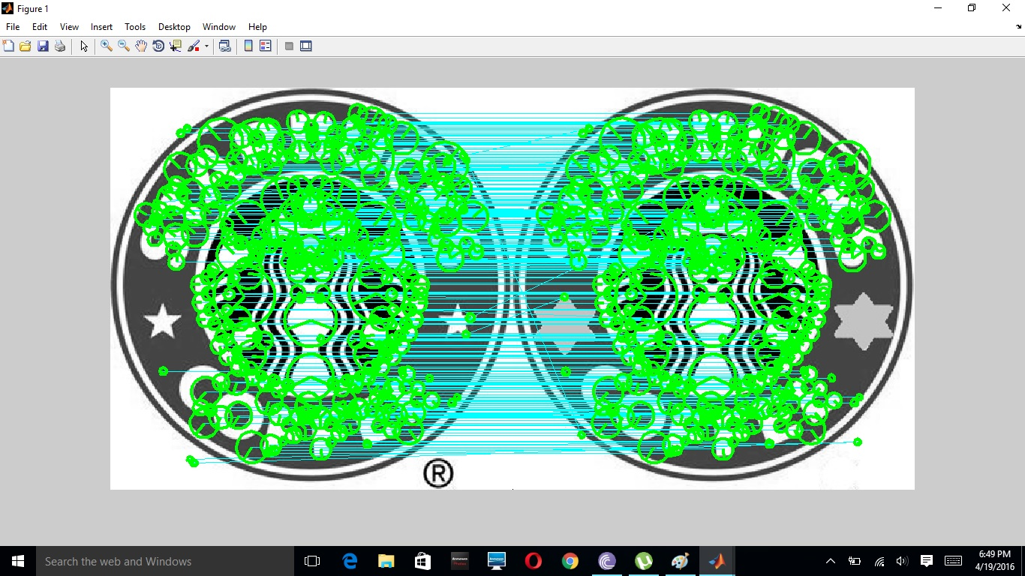

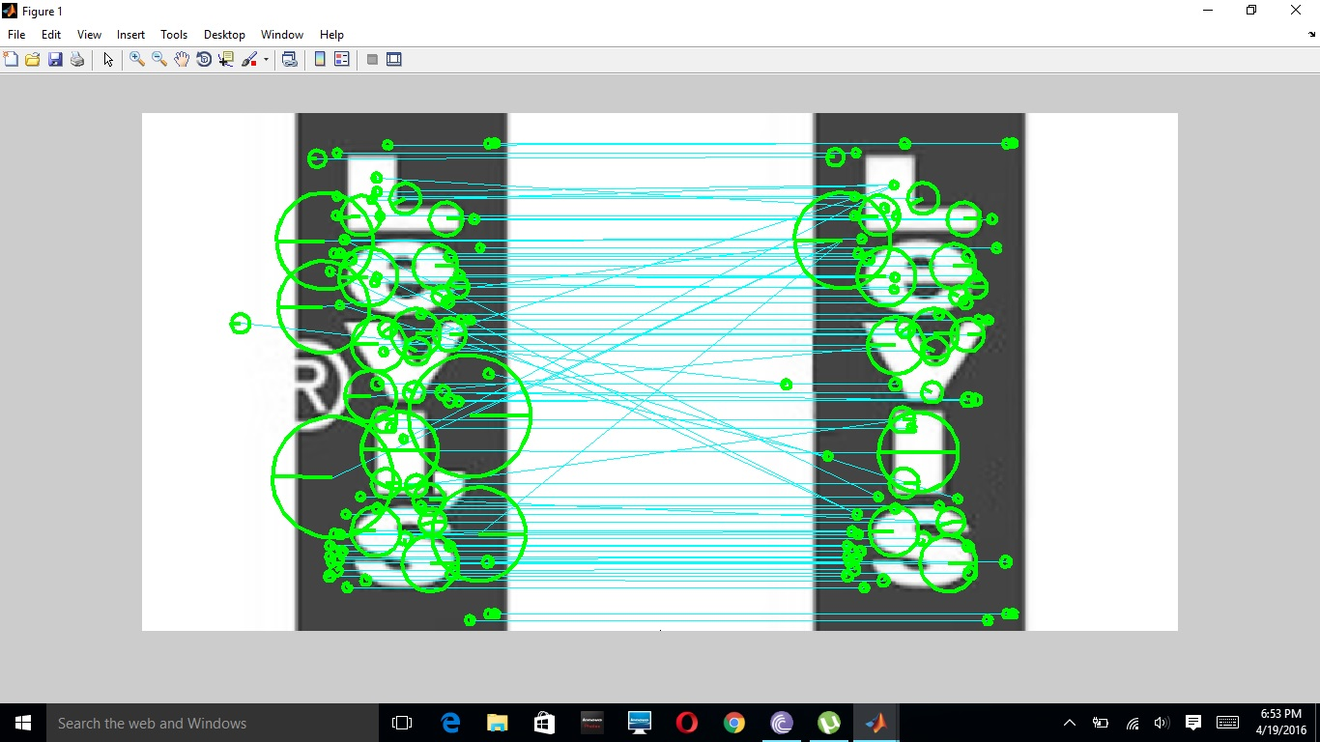

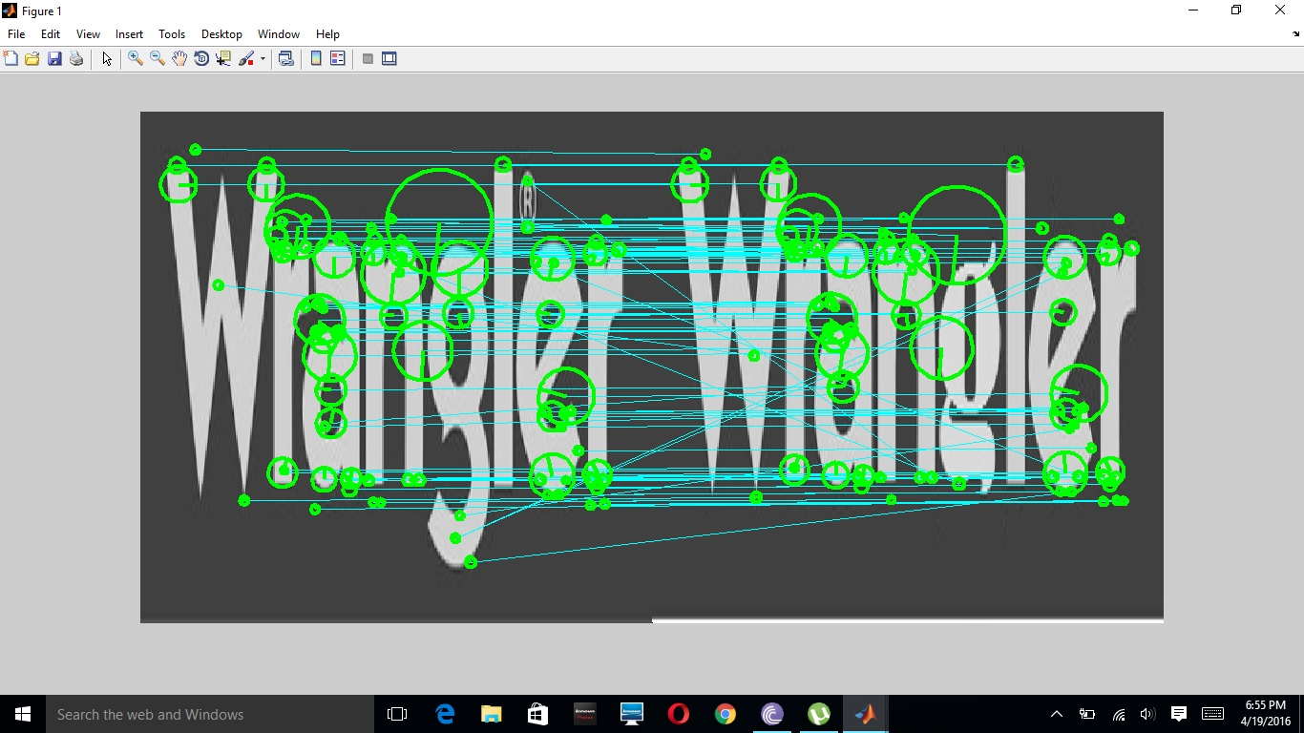

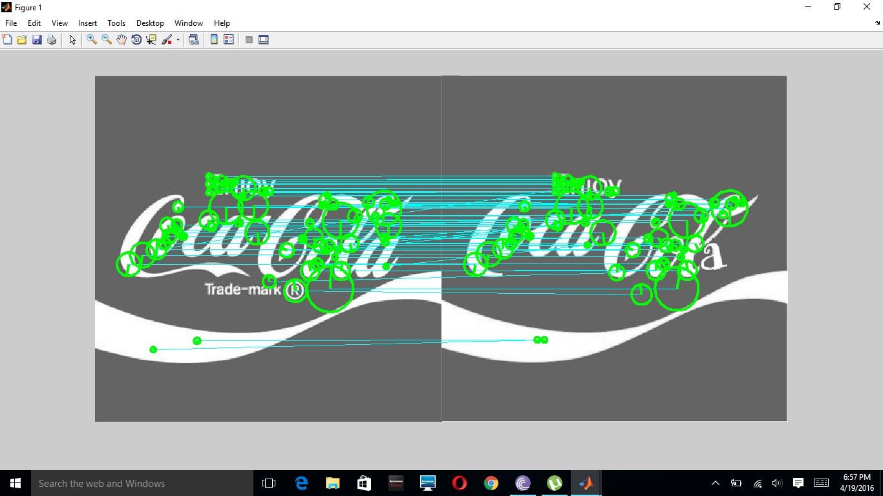

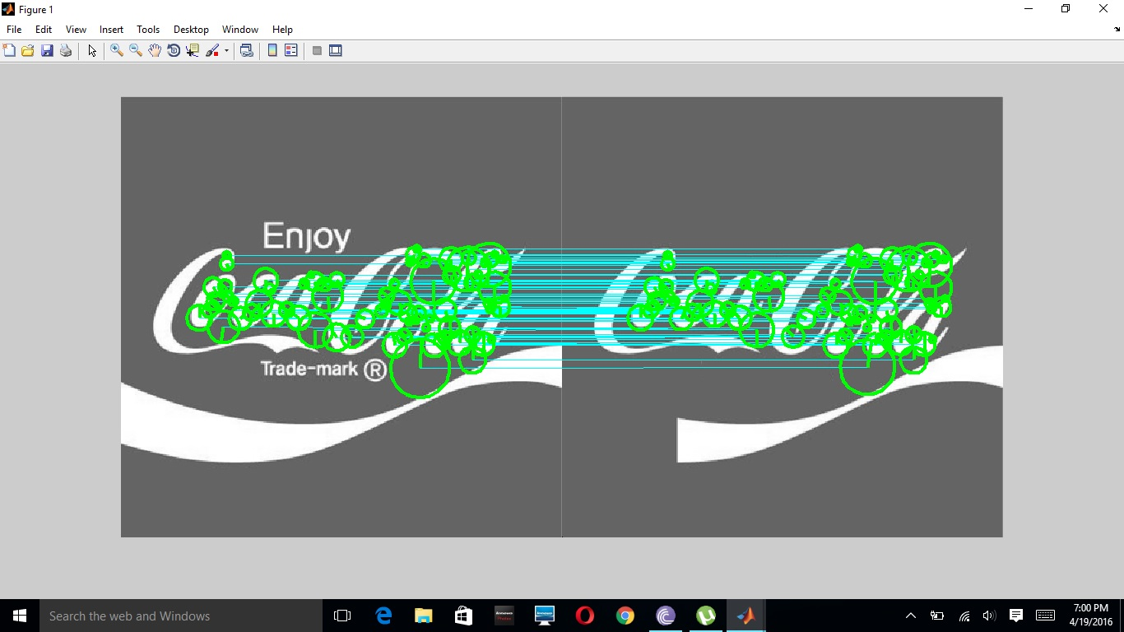

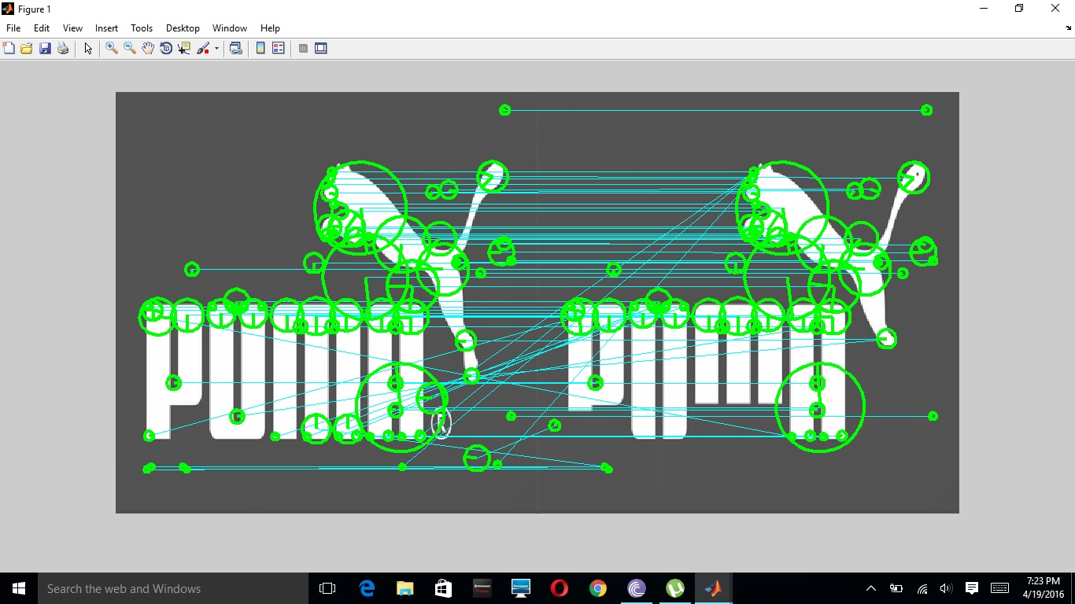

CHAPTER 5

**CONCLUSION**

We introduced in this work a novel logo detection and localization approach based on a new class of similarities referred to as context dependent. The strength of the proposed method resides in several aspects: (i) the inclusion of the information about the spatial configuration in similarity design as well as visual features, (ii) the ability to control the influence of the context and the regularization of the solution via our energy function, (iii) the tolerance to different aspects including partial occlusion, makes it suitable to detect both near-duplicate logos as well as logos with some variability in their appearance, and (iv) the theoretical groundedness of the matching framework which shows that under the hypothesis of existence of a reference logo into a test image, the probability of success of matching and detection is high. Further extensions of this work include the application of the method to logo retrieval in videos and also the refinement of the definition of context in order to handle other rigid and non-rigid logo transformations. Logos are often used pervasively as declaration of document source and ownership in business and government documents. The problem of logo detection and recognition is of great interest to the document image analysis and retrieval communities because it enables immediate identification of the source of documents based on the originating organization. Facing continually increasing volumes of documents, detecting and recognizing unique, evidentiary graphical symbols, such as logos [15] and signatures [18], is a practical and reliable supplement to the recognition of printed text using OCR and analysis of text by natural language processing. In the context of document image retrieval, logos provide an important form of indexing that enables effective exploration of data. In the following sections, we first motivate the problems of logo detection, segmentation, and matching for document image retrieval. We then present our approach to graphics recognition based on translation, scale, and oration-invariant shape descriptors and matching algorithms for generic 2-D feature points, with a focus on the logo matching problem.



Prior literature has focused almost exclusively on logo recognition [5, 8, 9, 12, 13]. These studies assume that an effective logo detection and segmentation approach is available. Recognition results are largely reported on the University of Maryland (UMD) Logo Database [7], which contains 105 distinct gray scale logo images. The UMD logo database, however, is far from a perfect recognition benchmark, because it contains only one logo instance per class. Some approaches were evaluated based on the task of group membership recognition (e.g. 6 classes in [13]) or subsets of the database (e.g. 20 logo classes in [5]), while others included their own logo collections [9, 12]. Furthermore, these approaches generated rotated, noise corrupted, or manually edited logos as test sets using different schemes, making direct comparison difficult.

A fundamental problem in the recognition of graphical symbols is the lack of a general representation based on generic, geometrically invariant features. Doorman et al. [8] extracts text and primitive shapes (lines, circles, and rectangles) from logos using many specific feature detectors, and use global and local geometric invariants for matching. Neumann et al. [12] uses projection profiles, normalized centroid distance, eccentricity, and various density features for logo recognition. These approaches have limitations. First, it is difficult to robustly extract high-level features (e.g. graphical, inverse, or circular text) in a geometrically invariant manner under diverse image qualities and degradations. Second, these methods are hard to extend because they are based on a collection of handpicked and trainable features and a variety of decision rules.



Logo Detection and Segmentation Detecting and segmenting free-form graphical patterns such as logos is challenging. Large variations in logo style (see Fig. 1) and low quality images can make detection difficult. Complicating matters, the foreground content of documents generally includes a mixture of machine printed text, diagrams, tables and other elements. From the application perspective, accurate localization is needed for logo recognition. Logo detector must consistently detect and extract complete logos while attempting to minimize the false alarm rate.

We extend our previous logo detection and segmentation approach [15], by incorporating a two-step, partially supervised learning framework that effectively deals with large variations. We learn the base detector—a Fisher classifier at a coarse image scale, from a small set of segmented images and test on a larger pool of unlabeled training images. We then bootstrap these detections to boost a cascade of classifiers at finer image scales, which allows false alarms to be quickly rejected and the detected logo to be more precisely localized. Our logo detection approach is segmentation free and layout independent. Interested readers can refer to [15] for details. Fig. 1 shows detected and segmented logos by our approach from the Tobacco-800 document image database We treat a logo as a non-rigid shape, and represent it by a discrete set of 2-D feature points extracted from the object. 2-D point features offer several advantages compared to other compact geometrical entities used in shape representation, because it relaxes the strong assumption that the topology and the temporal order of features are well preserved under image transformations and degradations. For instance, the same portion of contours in one logo sample may overlap, while appearing separated in other cases. Represented by a 2-D point distribution, a shape is more robust under image degradations and noise, while carrying discriminative shape information. As shown in Fig. 2, the shape of a logo is well captured by a finite set P = {P1, . . . , Pn}, Pi 2 R2, of n corner feature points computed from the edge image. We use two state-of-the-art shape matching algorithms for logo matching. The first method is based on the representation of shape contexts, introduced by Belonged et al. [2]. In this approach, a spatial histogram defined as shape context is computed for each point, which describes the distribution of the relative positions of all remaining points (see column 3 in Fig. 2). Prior to matching, the correspondences between points are solved first through weighted bipartite graph matching. Our second method uses the neighbourhood graph matching algorithm by Zheng and Doermann [14], which formulates shape matching as an optimization problem that preserves local structures (see column 4 in Fig. 2). This approach has an intuitive graph matching interpretation, where each point represents a vertex and two vertices are considered connected in the graph if they are neighbours. The problem of finding the optimal match between shapes is thus equivalent to maximizing the number of matched edges between their corresponding graphs under a one-to-one matching constraint. Computationally, neighbourhood graphs employ an iterative framework for estimating the correspondences and the transformation. In each iteration, graph matching is initialized as-





Figure 3: Anisotropic scaling and registration quality effectively capture shape differences. (a) Detected logos. (b) Extracted corners. (c) Matching results of first two logos using shape contexts. (d) Matching results of first and third logos using shape contexts. Corresponding points identified by shape matching are linked and unmatched points are shown in green. The computed affine maps are shown in figure legends .In the shape context distance [2], and subsequently updated through relaxation labelling for more globally consistent results. Treating graphics and symbols as 2-D point distributions broadens the space of dissimilarity metrics and enables effective shape matching based on the correspondences and the underlying transformations [19]. We introduce shape dissimilarity metrics that quantitatively measure anisotropic scaling and registration residual error, and present a supervised training framework for effectively combining complementary shape information from different dissimilarity measures by linear discriminate analysis (LDA). Feature Selection and Extraction Extracting robust and generic features that can be detected reliably is essential for matching as logos often appear as complex mixtures of graphics and formatted text. We extract corner features from detected logos as follows. We first extract the object contours from the edge image computed by the Canny edge detector [4] and fill in the gaps along the contours. We then use the corner detector of He and Yung [10]. It has shown excellent performance in applications involving real-world scenes compared to other popular feature detectors. It identifies an initial set of corner candidates from local curvature maxima and uses adaptive local thresholds and dynamic support regions to eliminate false corners. Fig. 3(b) shows extracted corners from detected and segmented logos in real document images. Measures of Shape Dissimilarity Several measures of shape dissimilarity have demonstrated success in object recognition and retrieval. One is the thin-plate spline bending energy Dbe, and another is the shape context distance Dsc.

As a conventional tool for interpolating coordinate mappings from R2 to R2 based on point constraints, the thinplate spline (TPS) is commonly used as a generic representation of non-rigid transformation [3]. The TPS bending energy Dbe [6] measures the amount of non-linear deformation to best warp the shapes into alignment. However, Dbe only measures the deformation beyond an affine transformation, and its functional is zero if the undergoing transformation is purely affine. The shape context distance Dsc between a template shape T composed of m points and a deformed shape D of n points is defined in [2] as measures with limited supervised training in the next subsection. Our first new measure of dissimilarity Das characterizes the amount of anisotropic scaling between two shapes. Anisotropic scaling is a form of affine transformation that involves change to the relative directional scaling [19]. As illustrated in Fig. 3, the stretching or squeezing of the scale in the computed affine map captures global mismatch in shape dimensions among all registered points, even in the presence of large intra-class variation. We compute the amount of anisotropic scaling between two shapes by estimating the ratio of the two scaling factors Sx and Sy in the x and y directions, respectively. A TPS transformation can be decomposed into a linear part corresponding to a global affine alignment, together with the superposition of independent, affine-free deformations (or principal warps) of progressively smaller scales [3]. We ignore the non-affine terms in the TPS interpolant when estimating Sx and Sy. The 2-D affine transformation is represented as a 2×2 linear transformation matrix A and a 2×1 translation vector T We propose another distance measure Dre based on the registration residual errors under the estimated nonrigid transformation. To minimize the effect of outliers, we compute the registration residual error from the subsetof points that have been assigned correspondence during matching, and ignore points matched to the dummy point nil. Let function M: Z+ ! Z+ define the matching between two point sets of size n representing the template shape T and the deformed shape D. Suppose ti and dM(i) for i = 1, 2, . . . , n denote pairs of matched points in shape T and shape D, respectively. Results and Discussion Table 1 summaries the performances of different matching algorithms in combination with different measures of shape dissimilarity. Both neighborhood graphs and shape contexts significantly outperform the correlation method. This demonstrates the competitive advantages f approaches based on 2-D feature matching in the recognitionof graphics and symbols. First, their shape descriptors are built from generic 2-D point distribution, which can be robustly extracted in practice. Second, these approaches solve the underlying transformations (affine for linear and TPS for non-linear transformation), which improves shape matching and discrimination. Shape contexts method gives the best logo matching performance as shown in Table 1. By incorporating rich global shape information, shape contexts descriptors are more robust under significant image degradations than neighborhood graphs, which capture local structures. Shape dissimilarity measures computed from anisotropic scaling, registration residual error, and the number of unmatched points significantly improve the retrieval performance, demonstrating that we can improve the retrieval quality considerably by combining complementary measures of shape dissimilarity. In addition, this experiment shows the effectiveness of learning the optimal weight associated with different dissimilarity metrics using LDA under limited supervised training. Evaluation Metrics We use two most commonly cited measures, average precision and R-precision, to evaluate the performance of each ranked retrieval. Average precision (AP) rewards retrieval systems that rank relevant documents higher, and at the same time penalizes those that rank irrelevant ones higher. R-precision (RP) de-emphasizes the exact ranking among the retrieved relevant documents and is more useful when there are a large number of relevant documents. The overall system performance across all queries are computed quantitatively in mean average precision (MAP) and mean R-precision (MRP), respectively.

We demonstrate performance using the 1, 290-image Tobacco-800 database [1, 16]. Tobacco-800 is a public subset of the IIT CDIP Test Collection and has been used in TREC 2006 and 2007 evaluations [1]. It is a realistic, complex dataset for document analysis and retrieval, because these documents were collected and scanned using a wide variety of equipment over time [11]. The image resolutions range from 150 to 300 DPIs and their qualities vary considerably. The Tobacco-800 collection and its associated groundtruth is available in XML format at [16]. We tested our system using a total of 386 logos across 35 classes detected from the Tobacco-800 dataset, among which the number of logos per class varies in the range. In this paper, we have presented an approach to automatically detecting, segmenting, and matching logos from documents with unconstrained layouts and complex background for document retrieval. To robustly handle variety of image qualities and degradations, we treated the logo in the unconstrained setting of a non-rigid shape and demonstrated document image retrieval using state-of-the-art shape representations, measures of shape dissimilarity, and shape matching algorithms. We quantitatively evaluated the effectiveness of our approach in challenging retrieval tests using public, real-world document image collections involving a large number of classes but relatively small numbers of logo instances per class.

**CHAPTER 6**

**SOURCE CODE**

%%%%%%%%%%Context-Dependent Logo Matching and Recognition%%%%%%%%%

clc;

clear all;

close all;

run('toolbox/vl_setup')

database_dir = 'Database';

%query_image = 'Query/coke.jpg';

query_image = 'Query/starbucks.jpg';

%query_image = 'Query/coke.jpg';

%query_image = 'Query/starbucks.jpg';

coke_que = false(1,5); coke_que(1:5)=true;

starbucks_que = false(1,5); starbucks_que(6:10)=true;

apple_que = false(1,5); apple_que(11:15)=true;

kingfisher_que = false(1,5); kingfisher_que(16:21)=true;

que=apple_que;

img = single(rgb2gray(imread(query_image)));

aa=[400 400];

img=imresize(img,aa);

num=zeros(1,2);

show = true;

for l=1:22;

out_images = [database_dir '/' num2str(l) '.jpg'];

tic;

img_que=imread(out_images);

if ndims(img_que) == 3

img_que=single(rgb2gray(img_que));

else

img_que=single(img_que);

end

img_que=imresize(img_que,aa);

[frames_query,sift_query] = vl_covdet(img,'Method','DoG','EstimateOrientation',true,'DoubleImage',false);

[frames_test,sift_test] = vl_covdet(img_que,'Method','DoG','EstimateOrientation',true,'DoubleImage',false);

threshold=1.5;

[matches,score] = vl_ubcmatch(sift_query,sift_test,threshold);

loc1 = frames_query(1:2,:)';

loc2 = frames_test(1:2,:)';

if(show)

im = appendimages(uint8(img),uint8(img_que));

close all;

figure('Position', [100 100 size(im,2) size(im,1)]);

imshow(im);

hold on;

cols1 = size(img,2);

for i = 1:size(matches,2)

line([loc1(matches(1,i),1) loc2(matches(2,i),1)+cols1], ...

[loc1(matches(1,i),2) loc2(matches(2,i),2)], 'Color', 'c');

end

vl_plotframe(frames_query(:,matches(1,:)));

vl_plotframe(frames_test(:,matches(2,:))+repmat([cols1 0 0 0 0 0]',1,size(matches,2)))

hold off;

pause;

end

toc;

end

**CHAPTER 7**

**REFERENCES**

[1] A. Smeulders, M. Worring, S. Santini, A. Gupta, and R. Jain, “Contentbased image retrieval at the end of the early years,” *IEEE Trans. Pattern Anal. Mach. Intell.*, vol. 22, no. 12, pp. 1349–1380, Dec. 2000.

[2] R. Datta, D. Joshi, J. Li, and J. Z. Wang, “Image retrieval: Ideas, influences, and trends of the new age,” *ACM Comput. Surv.*, vol. 40, no. 2, pp. 1–60, 2008.

[3] L. Ballan, M. Bertini, A. Del Bimbo, L. Seidenari, and G. Serra, “Event detection and recognition for semantic annotation of video,” *Multimedia Tools Appl.*, vol. 51, no. 1, pp. 279–302, 2011.

[4] Y. Jing and S. Baluja, “Pagerank for product image search,” in *Proc. WWW*, Beijing, China, 2008, pp. 307–316.

[5] L. Ballan, M. Bertini, and A. Jain, “A system for automatic detection and recognition of advertising trademarks in sports videos,” in *Proc. ACM Multimedia*, Vancouver, BC, Canada, 2008, pp. 991–992.

[6] A. Watve and S. Sural, “Soccer video processing for the detection of advertisement billboards,” *Pattern Recognit. Lett.*, vol. 29, no. 7, pp. 994–1006, 2008.

[7] C. Constantinopoulos, E. Meinhardt-Llopis, Y. Liu, and V. Caselles, “A robust pipeline for logo detection,” in *Proc. IEEE Int. Conf. Multimedia Expo*, Barcelona, Spain, Jul. 2011, pp. 1–6.

[8] J.-L. Shih and L.-H. Chen, “A new system for trademark segmentation and retrieval,” *Image Vis. Comput.*, vol. 19, no. 13, pp. 1011–10 18, 2001.

[9] C.-H. Wei, Y. Li, W.-Y. Chau, and C.-T. Li, “Trademark image retrieval using synthetic features for describing global shape and interior structure,” *Pattern Recognit.*, vol. 42, no. 3, pp. 386–394, 2009.

[10] M. Merler, C. Galleguillos, and S. Belongie, “Recognizing groceries in situ using in vitro training data,” in *Proc. IEEE Comput. Vis. Pattern Recognit. SLAM Workshop*, Minneapolis, MN, May 2007, pp. 1–8.

[11] Y. S. Kim and W. Y. Kim, “Content-based trademark retrieval system using visually salient feature,” in *Proc. IEEE Conf. Comput. Vis. Pattern Recognit.*, San Juan, Puerto Rico, Mar. 1997, pp. 307–312.

[12] A. Jain and A. Vailaya, “Shape-based retrieval: A case study with trademark image databases,” *Pattern Recognit.*, vol. 31, no. 9, pp. 1369– 1390, 1998.

[13] J. P. Eakins, J. M. Boardman, and M. E. Graham, “Similarity retrieval of trademark images,” *IEEE Multimedia*, vol. 5, no. 2, pp. 53–63, Apr.–Jun. 1998.

[14] J. Schietse, J. P. Eakins, and R. C. Veltkamp, “Practice and challenges in trademark image retrieval,” in *Proc. ACM Int. Conf. Image Video Retr.*, Amsterdam, The Netherlands, 2007, pp. 518–524.

[15] T. Kato, “Database architecture for content-based image retrieval,” *Proc. SPIE, Image Storage Retr. Syst.*, vol. 1662, no. 1, pp. 112–123, Jan. 1992.

[16] S. Belongie, J. Malik, and J. Puzicha, “Shape matching and object recognition using shape contexts,” *IEEE Trans. Pattern Anal. Mach. Intell.*, vol. 24, no. 4, pp. 509–522, Apr. 2002.

[17] J. Rodriguez, P. Aguiar, and J. Xavier, “ANSIG—An analytic signature for permutation-invariant two-dimensional shape representation,” in *Proc. IEEE Conf. Comput. Vis. Pattern Recognit.*, Anchorage, AK, Jun. 2008, pp. 1–8.

[18] J. Luo and D. Crandall, “Color object detection using spatial-color joint probability functions,” *IEEE Trans. Image Process.*, vol. 15, no. 6, pp. 1443–1453, Jun. 2006.

[19] R. Phan, J. Chia, and D. Androutsos, “Unconstrained logo and trademark retrieval in general color image databases using color edge gradient cooccurrence histograms,” in *Proc. IEEE Int. Conf. Acoust. Speech Signal Process.*, Las Vegas, NV, Mar.–Apr. 2008, pp. 1221–1224. [20] R. Phan and D. Androutsos, “Content-based retrieval of logo and trademarks in unconstrained color image databases using color edge gradient co-occurrence histograms,” *Comput. Vis. Image Understand.*, vol. 114, no. 1, pp. 66–84, 2010.

[21] J. Matas, O. Chum, M. Urban, and T. Pajdla, “Robust wide-baseline stereo from maximally stable extremal regions,” *Image Vis. Comput.*, vol. 22, no. 10, pp. 761–767, 2004.

[22] D. Lowe, “Distinctive image features from scale-invariant keypoints,” *Int. J. Comput. Vis.*, vol. 60, no. 2, pp. 91–110, 2004.

[23] H. Bay, A. Ess, T. Tuytelaars, and L. Van Gool, “Speeded-up robust features (SURF),” *Comput. Vis. Image Understand.*, vol. 110, no. 3, pp. 346–359, 2008.

[24] J. Sivic and A. Zisserman, “Video Google: A text retrieval approach to object matching in videos,” in *Proc. Int. Conf. Comput. Vis.*, vol. 2. Nice, France, 2003, pp. 1470–1477.

[25] J. Sivic and A. Zisserman, “Efficient visual search of videos cast as text retrieval,” *IEEE Trans. Pattern Anal. Mach. Intell.*, vol. 31, no. 4, pp. 591–606, Apr. 2009.

[26] A. D. Bagdanov, L. Ballan, M. Bertini, and A. Del Bimbo, “Trademark matching and retrieval in sports video databases,” in *Proc. ACM Int. Workshop Multimedia Inf. Retr.*, Augsburg, Germany, 2007, pp. 79–86.

[27] A. Joly and O. Buisson, “Logo retrieval with a contrario visual query expansion,” in *Proc. ACM Multimedia*, Beijing, China, 2009, pp. 581– 584.

[28] O. Chum, M. Perdoch, and J. Matas, “Geometric min-hashing: Finding a

(thick) needle in a haystack,” in *Proc. IEEE Conf. Comput. Vis. Pattern*

*Recognit.*, Miami, FL, Jun. 2009, pp. 17–24.

[29] Z. Wu, Q. Ke, M. Isard, and J. Sun, “Bundling features for large scale

partial-duplicate web image search,” in *Proc. IEEE Conf. Comput. Vis.*

*Pattern Recognit.*, Miami, FL, Mar. 2009, pp. 25–32.

[30] S. Lazebnik, C. Schmid, and J. Ponce, “Beyond bags of features: Spatial

pyramid matching for recognizing natural scene categories,” in *Proc.*

*Conf. Comput. Vis. Pattern Recognit.*, vol. 2. 2006, pp. 2169–2178.

[31] R. Fergus, P. Perona, and A. Zisserman, “Object class recognition

by unsupervised scale-invariant learning,” in *Proc. Conf. Comput. Vis.*

*Pattern Recognit.*, vol. 2. Madison, WI, 2003, pp. 264–271.

[32] G. Carneiro and A. Jepson, “Flexible spatial models for grouping local

image features,” in *Proc. Conf. Comput. Vis. Pattern Recognit.*, vol. 2.

Washington, DC, 2004, pp. 747–754.

[33] O. Chum and J. Matas, “Unsupervised discovery of co-occurrence in

sparse high dimensional data,” in *Proc. Conf. Comput. Vis. Pattern*

*Recognit.*, San Francisco, CA, 2010, pp. 3416–3423.

[34] C. Pantofaru, G. Dorko, C. Schmid, and M. Hebert, “Combining regions

and patches for object class localization,” in *Proc. Conf. Comput. Vis.*

*Pattern Recognit. Beyond Patches Workshop*, 2006, pp. 1–8.

[35] E. Mortensen, H. Deng, and L. Shapiro, “A SIFT descriptor with global

context,” in *Proc. Conf. Comput. Vis. Pattern Recognit.*, San Diego, CA,

2005, pp. 184–190.

[36] A. M. Bronstein and M. M. Bronstein, “Spatially-sensitive affineinvariant

image descriptors,” in *Proc. Eur. Conf. Comput. Vis.*, vol. 2.

Crete, Greece, 2010, pp. 197–208.

[37] K. Gao, S. Lin, Y. Zhang, S. Tang, and D. Zhang, “Logo detection based

on spatial-spectral saliency and partial spatial context,” in *Proc. IEEE*

*Int. Conf. Multimedia Expo*, 2009, pp. 322–329.

[38] J. Kleban, X. Xie, and W.-Y. Ma, “Spatial pyramid mining for logo

detection in natural scenes,” in *Proc. IEEE Int. Conf. Multimedia Expo*,

Hannover, Germany, 2008, pp. 1077–1080.

[39] T. Quack, V. Ferrari, B. Leibe, and L. Van Gool, “Efficient mining

of frequent and distinctive feature configurations,” in *Proc. Int. Conf.*

*Comput. Vis.*, Rio de Janeiro, Brazil, 2007, pp. 1–8.

[40] H. Sahbi, J.-Y. Audibert, J. Rabarisoa, and R. Kerivan, “Contextdependent

kernel design for object matching and recognition,” in *Proc.*

*IEEE Conf. Comput. Vis. Pattern Recognit.*, Anchorage, AK, 2008, pp.

1–8.

[41] H. Sahbi, J.-Y. Audibert, and R. Kerivan, “Context-dependent kernels for

object classification,” *IEEE Trans. Pattern Anal. Mach. Intell.*, vol. 33,

no. 4, pp. 699–708, Apr. 2011.

[42] Y. Kalantidis, L. G. Pueyo, M. Trevisiol, R. van Zwol, and Y. Avrithis,

“Scalable triangulation-based logo recognition,” in *Proc. ACM Int. Conf.*

*Multimedia Retr.*, Trento, Italy, 2011, pp. 1–7.